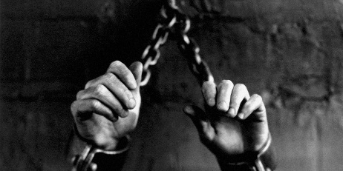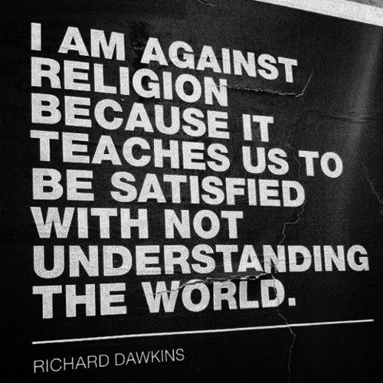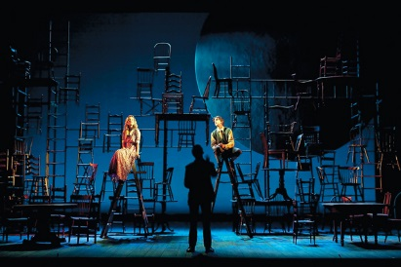

Blue colours and shadows to create space imagery linking with the theme of human existence. Could use drapes and cyc. Structures relating to science particles etc and tables could be created with set furniture like this.

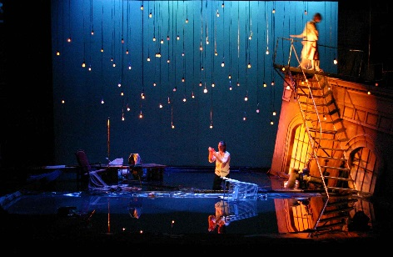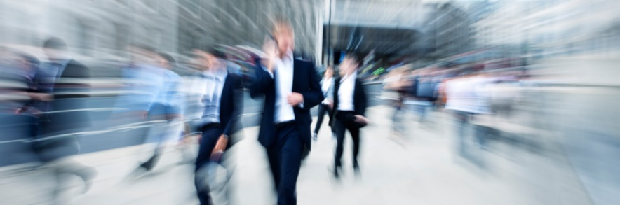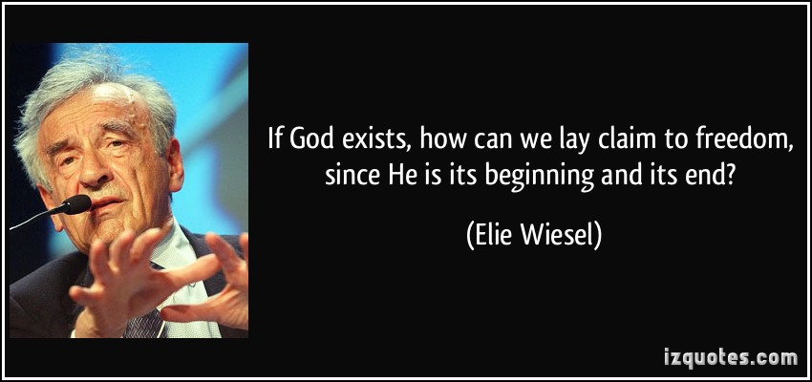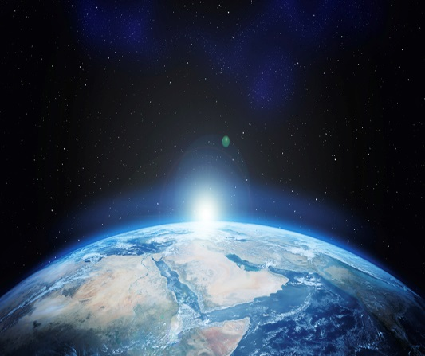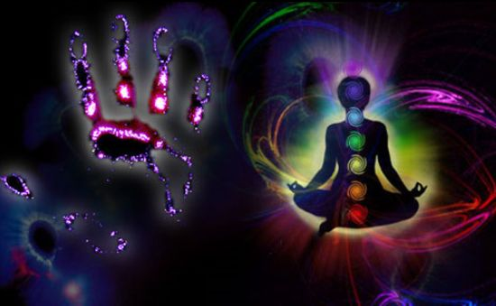

Set should show contrast of science astrology, and religion through drapes and hanging decor. Science element in shadows astrology in light and religion interfering with the connections.

Set design must convey a sense of being trapped to show that human beings aren’t really free to live how they want to. Maybe bars or cages

Modern merging shapes indicating the speed of modern life = time and place

Hand sign on flats symbolising the soul and astrology. Something beyond modern religion binding us together.

Black curtains decorated to indicate infinity beyond human existence. When the actors go off stage they go into infinity

*Brave New World*

Design Mood Board